**G-Sec / T-bills Transfer to MCCIL**

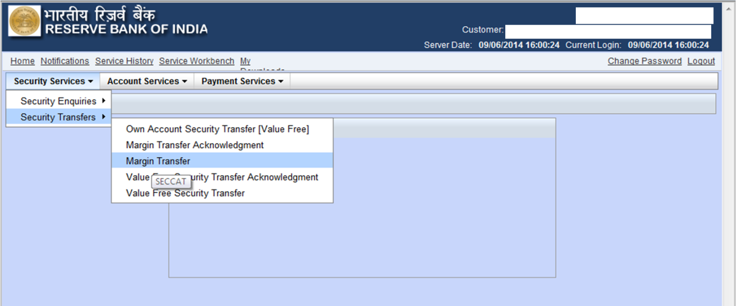

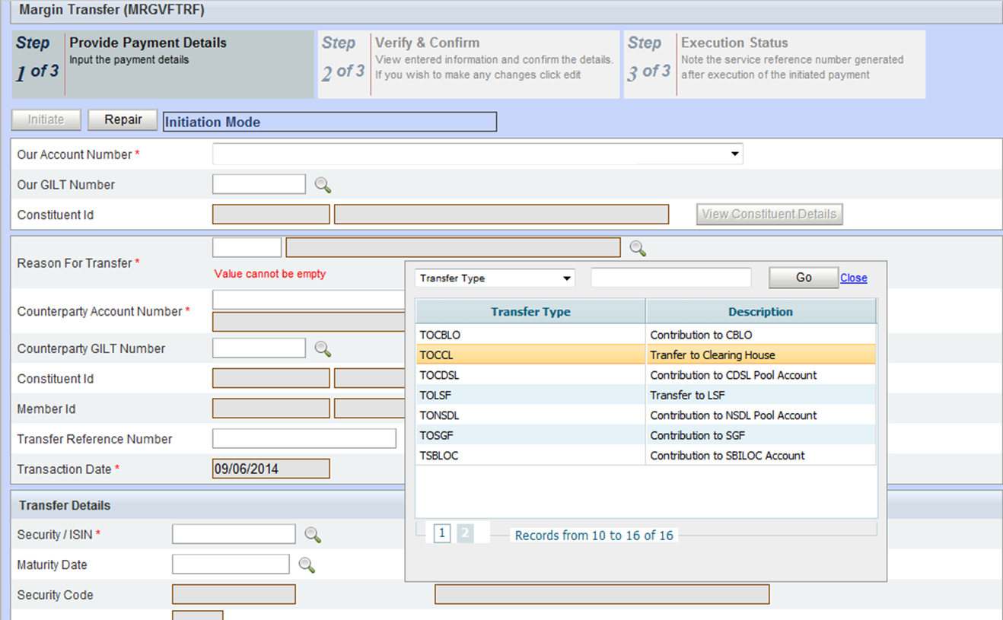

**G-Sec / T-bills Transfer from MCCIL**

